Physics 3A/3B

Particle Waves and Quanta

Test

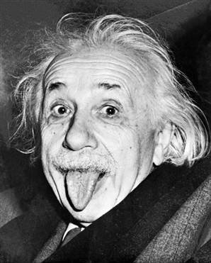

Time allowed: max 40 min
Answer all questions on the paper provided
To achieve full marks, clear, logical
working and diagrams MUST be shown.
Answers should be evaluated with an
appropriate number of significant figures.

Special answer sheet required
Section A: 11 questions worth 20 marks

1. Three students are using a piece of string to make a standing wave. The following graph shows the wavelength of part of the string at one particular instance. What is the amplitude and wavelength of the wave the string creates. (2 marks)
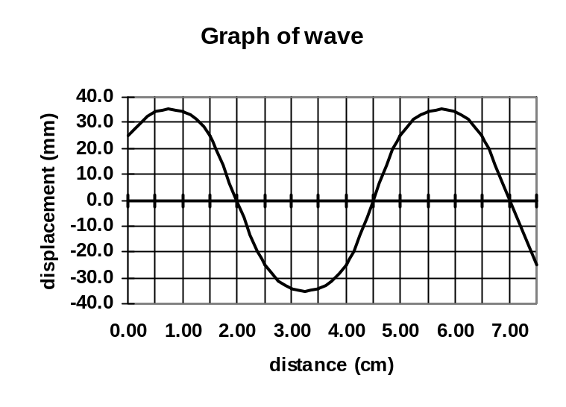

a) 3.5 x 10⁻² m ( 1 mark )
b) 5 x 10⁻² m (1 mark ) Not in SI unit = 1 Mark only

2. If the wave in the graph for question (1) is travelling at 4.00 ms⁻¹, what is the period of the wave? (3 marks)
v = λf
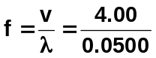

T = 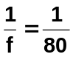 T = 0.0125
T = 1.25 x 10⁻² s

3. A student has set up two waves on a dual beam CRO. She then adds them together. Using the special answer sheet, draw the resultant wave. (2 marks)

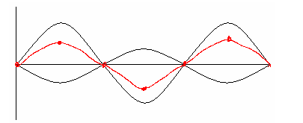

4. Using the special answer sheet complete the following diagrams for reflection of waves at a harbour wall and the refraction of sound of a bell above water.
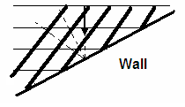
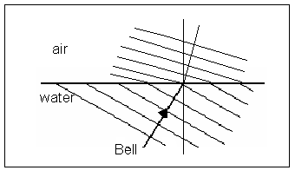
(3 marks)

1 mark (direction + Waves) 2 Marks (Direction 1, Wavelength decrease 1)

5. Matt was running his finger around the top of a wine glass. He then increases the speed until it sounds a note. Explain why the glass sounds the note and what is the name given to this phenomena?
(3 marks)
Phenomena is resonance. (1)
- finger running around top produces the driving frequency
- When frequency of forced vibrations matches natural frequency of glass, maximum transference of energy occurs (1)
- Amplitude of vibrations of glass greatly increased and a sound is produced. (1)

6.
With the aid of diagrams and calculations determine the length of a tube, which is closed at one end, required to produce a fundamental frequency of 256 Hz?
(3 marks)
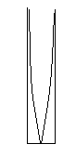
λ = 4L v = f x λ
346 = 256 x 4 L
L = 3.38 x 10⁻¹ m ( 2 marks )

(1 mark)

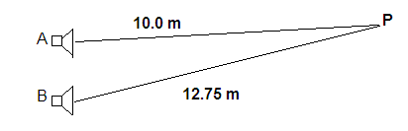
11. The two speakers below are producing a 680 Hz note. Assume the speed of sound in air is 340 ms⁻¹. Point P is 10.00 m from speaker A and 12.75 m from speaker B.

Determine if there is a node or anti-node at point P and what would be heard at this point. You must justify your answer to receive any marks. The wave position next to the speakers is an anti-node. A diagram may assist your answer.
(4 marks)

f = 680 Hz 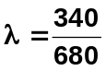
v = 346 m s⁻¹ λ = 0.500 m (1 mark)

Consider wave A
λ = 0.5 m 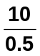 = 20 full waves, Antinode (1 mark)

Consider wave B
λ = 0.5 m 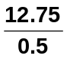 = 25.5 Antinode (1 mark)

Path difference is 5.5 waves, crest meets trough therefore destructive interference. Nil sound or low sound
(1 mark)

Section B: 1 questions worth 10 marks

A Catholic Priest by the name of Marin Mersenne was credited with have discovered the laws of stretched strings. He discovered the following relationship:

f = 1√T
2L √μ
F = frequency (Hz)
L = length (m)
T = tension (N)
μ = mass per unit length

The following data was collected using a fixed string and a frequency generator. The tension was achieved by hanging masses on the end of the string. Masses were added to the string and the frequency adjusted until the first harmonic was observed. The following data was collected.

Length of string – 64 cm

Tension N | Frequency Hz | √T
5.00 | 256 | 2.236068
6.00 | 288 | 2.44949
9.00 | 320 | 3
10.0 | 341 | 3.162278
12.0 | 384 | 3.464102
14.0 | 427 | 3.741657
18.0 | 480 | 4.242641
22.0 | 512 | 4.690416

a) After manipulating the data as required plot a graph to show a linear relationship between frequency and tension.
(4 marks)
1mark for conversion T to √T OR f²
2 mark for correct axis and units and title
1 mark for line of best fit (goes through zero)

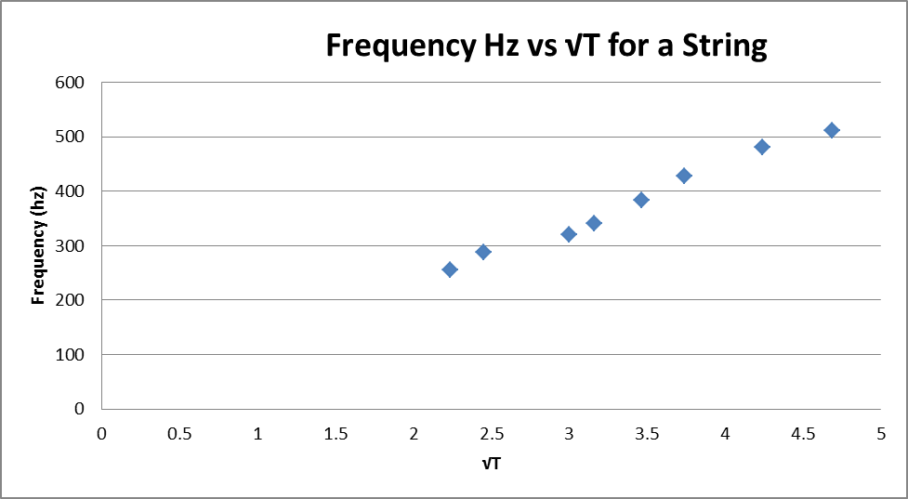

b) Write an expression for the relationship between frequency and tension
(1 mark)
f ∞ √T or f ² ∞ T
c) Using your graph to determine the value of μ.
(2 marks)

Gradient Calc (1)
Correctly applies Gradient to equation (1)

From y = mx +c
F = 1 √T
2L √μ
m = 1 (Gradient)
2L √μ

μ = 1/(2Lm)²

= 1/(2 x 0.64 x 108)²

= 5.23 x 10⁻⁵ kgm⁻¹ marks for process

d) With the aid of diagrams calculate the frequency of the third harmonic for a tension of 6.00 N.
(3 marks)
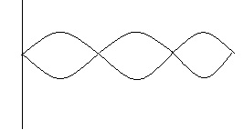
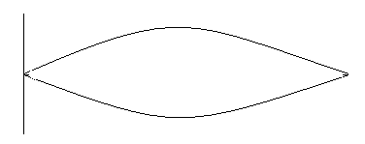

F1 = v/λ F2 = v/λ
= v/2L = 3v/2L
= 3 F1
=3 x 288
= 864 Hz

